**Subject: A**

1. **Describe Moore’s law. What consequence does it have, advantage / disadvantage?**
2. **Superscalar Machines. Advantages of this design? Does it improve the performance? How? What is the connection whit pipelined? Motivate. Give examples**
3. **What does the circuit do? Provide a short description and a simple I/O which illustrate you answer. It’s a combinatorial circuit? Why?**
4. **What is a trap? What is a interrupt? How are they handled? Give examples of typical trap, interrupt. Discus common features and difference, if any.**

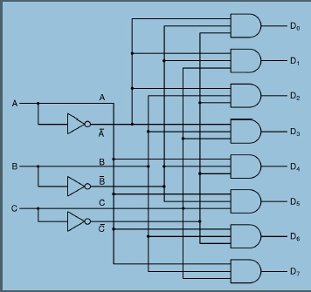

1. **Discus the impact of different branch instructions on the execution of a program pipeline machine. Dynamic branch predictions. How is it implemented ?**
2. **RISC architecture? The design principles? The main characteristic of a architecture? Compare with other architectures, advantages/disadvantages.**
3. **One’s complement intiger representation in 8 bites. Give a range of nr that can be represented , also the representation of 0 , maxim, minim. How is adition in one’s complement done? Perform the following operations in one’s complement:**

$$\frac{\begin{aligned} 11111111 \\ +11111111\end{aligned}}{} \frac{\begin{aligned} 11110111 \\ -11110111\end{aligned}}{} \frac{\begin{aligned} 11110111 \\ +11110111\end{aligned}}{}$$

**Scuze dar exercitiul 8 nu`l mai stiu.**